1. Summarize from p.64 to p.72 in chapters 5 in the text book.

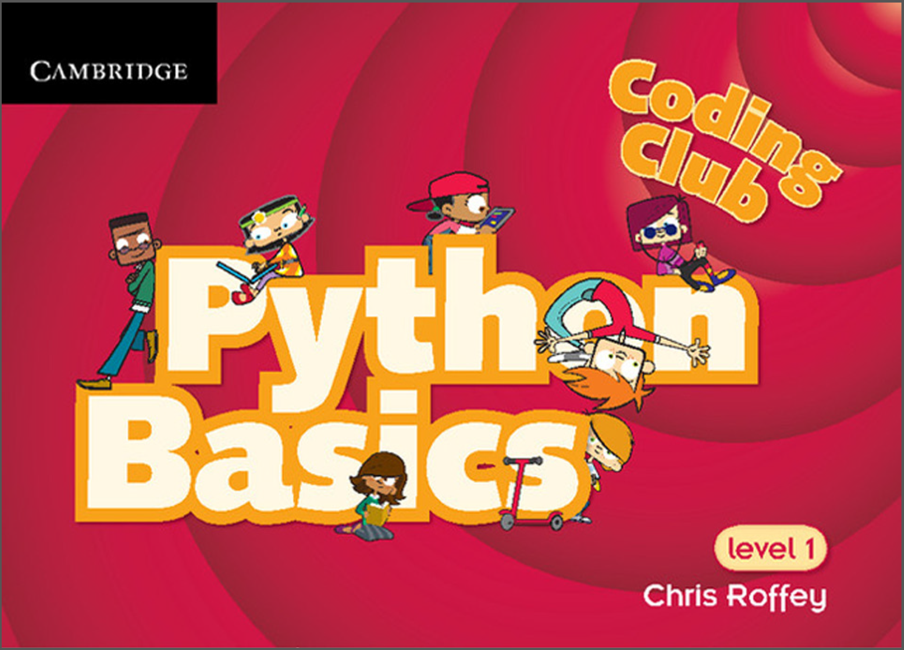

1. Make your own codes for all the ideas and puzzles in each chapter provided in the textbook. And take a picture of the solutions and attach the picture to the assignment file.